Trucent Separation Technologies, LLC Announces CORE™, Corn Oil Refinement Equipment Modules, to Produce TruDCO™

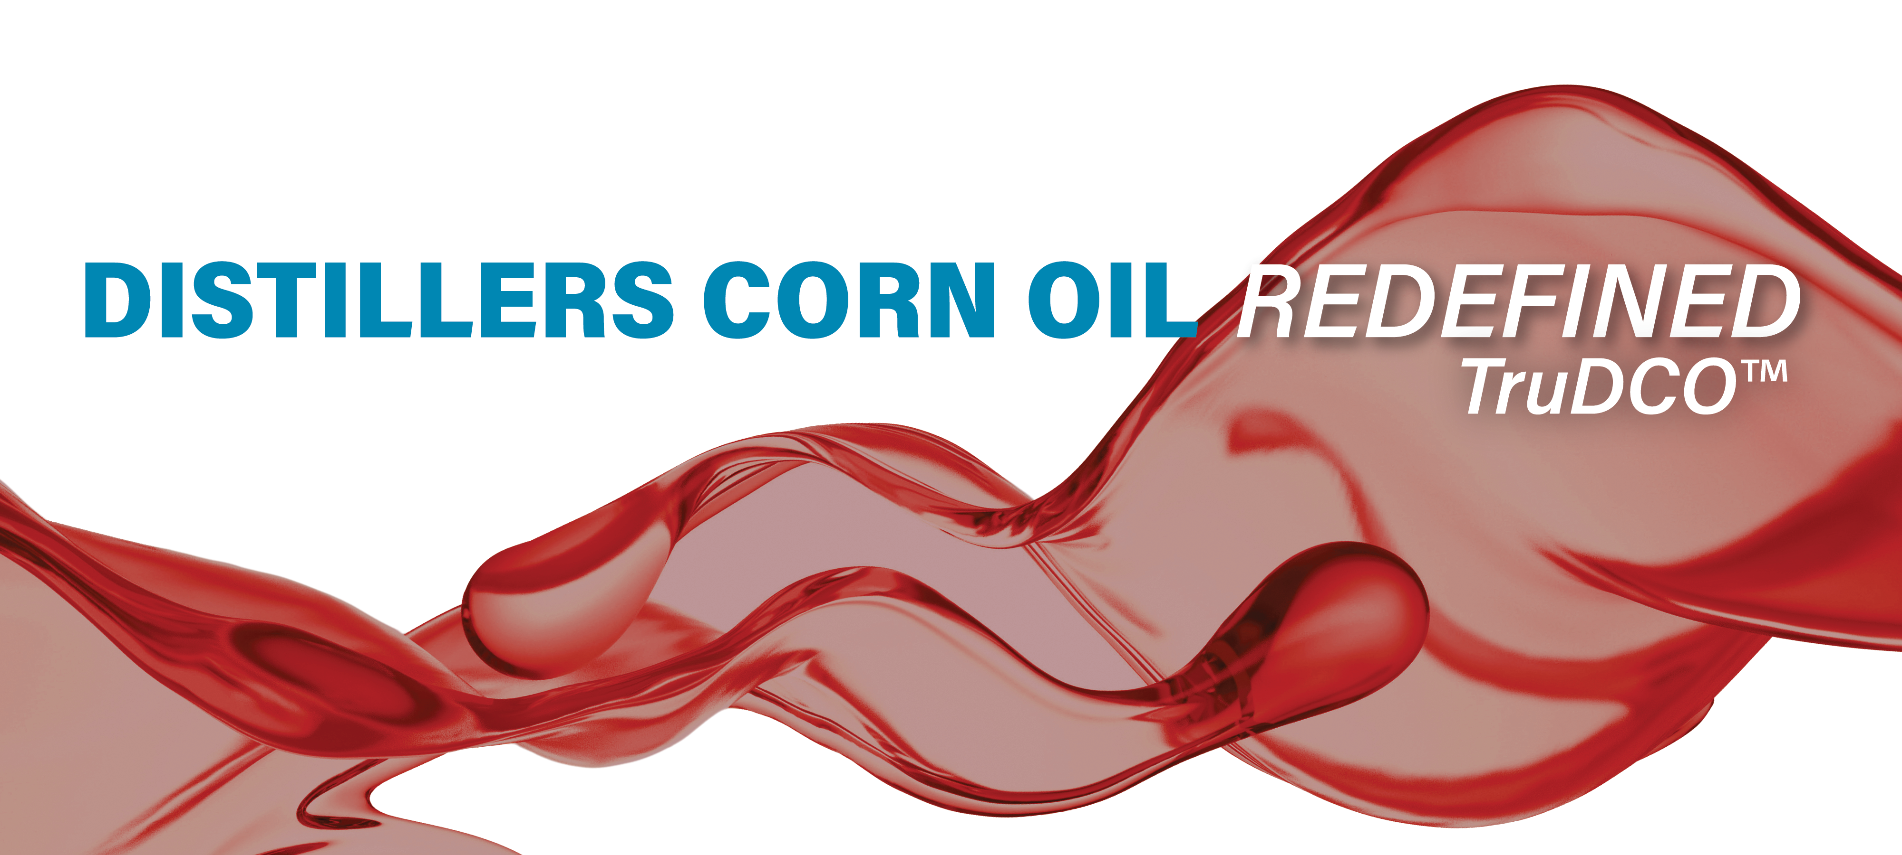
Thursday, June 9, 2022
Dexter, Michigan – Trucent Separation Technologies, LLC announced the launch of CORE™, a new technology to significantly reduce impurities in distillers corn oil (DCO), resulting in a cleaner oil, TruDCO™, which can be sold directly to renewable diesel refineries. The full-scale demonstration unit of CORE™ has been commercialized in conjunction with The Andersons, Inc. and is consistently producing TruDCO™ for direct sale to renewable diesel refineries at a premium above crude DCO.
The CORE™ module for the ethanol industry features an operator-friendly, efficient, bolt-on skid-mounted process with a small footprint, low operating costs and a quick ROI. “We’re excited to introduce customers to the benefits of adopting this new technology to elevate and redefine distillers corn oil for direct use in renewable diesel refineries,” said Tara Vigil, Trucent Vice President/GM, Bioprocess Solutions. “The CORE™ technology suite aligns well with Trucent’s global directive to maximize renewable resource use and drive profitability in ways that do good for our Earth while improving the quality of business operations.”
This advancement in oil treatment technology was born out of years of vegetable oil processing experience in combination with proprietary fluid separation process techniques and solutions developed by Trucent. The result is a unique and robust modular technology that can be implemented at any facility currently producing DCO or other crude renewable oils. Operation of CORE™ to produce TruDCO™ provides plants an opportunity for meaningful revenue enhancement by elevating their crude distillers corn oil to a ready-made low-carbon-intensity feedstock for the ever-expanding renewable diesel industry.
CORE™ draws upon Trucent’s extensive experience in fluid separation technology and exceptional services, and with The Andersons, is supplied with a distinctive Early-Adopter Support Program comprised of analytical, quality, technical, and operational support together with a comprehensive oil marketing program. Benefits of the Early-Adopter Support Program include:
- Comprehensive analytical equipment and tools to measure TruDCO™ product quality, as well as analytical training, validation, service, and support
- Routine technical and operational support of the CORE™ module, including specialized technology parts, maintenance assistance, and oversight
- Oil sales and marketing services exclusively provided by The Andersons, a recognized industry leader in customer relationships, knowledge, and innovation

CORE™ technology together with the Early-Adopter Support Program are currently available exclusively through Trucent and The Andersons.

About Trucent Separation Technologies, LLC – Bioprocess Solutions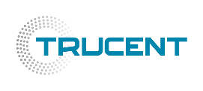
As a service and technology provider to the ethanol industry since 2005, Trucent knows that DCO is one of the most important coproduct revenue streams for ethanol facilities. While others are satisfied with meeting only customers’ most pressing needs, Trucent reaches higher. The pursuit of new technologies and partnerships centered on solving customers’ most demanding output and production challenges is at Trucent’s core. The experienced solutions team at Trucent harnesses knowledge, data, and unmatched service to expand the story of corn oil extraction. The Bioprocess Solutions team also applies its technical expertise to the Vegetable Processing, Biotechnology, Biodiesel industries, and more. Learn more at: www.trucent.com.

Contacts
Trucent Separation Technologies, LLC Contact
Tara Vigil | Vice President and GM Bioprocess Solutions | 734.253.2870 | tvigil@trucent.com

